**MINIMUM VARIABLE PRODUCT**

**Overview**

The Maze Project, a 3D game developed solely by myself using raycasting, has progressed significantly following the specified guidelines and requirements.

**Technical Details**

**Platform and Compilation**

All project files have been successfully compiled on Ubuntu 14.04 LTS, employing gcc (Ubuntu 4.8.4-2ubuntu1~14.04) 4.8.4, adhering strictly to the designated gcc flags (-Wall -Werror -Wextra -pedantic).

**Code Structure and Functionality**

The entire codebase maintains adherence to the outlined organizational structure. All functions are meticulously commented, ensuring clarity and understanding. Function sizes are limited to a maximum of 40 lines, adhering strictly to one statement per line and an 80-column limit, fostering readability and maintainability.

**File Organization**

The repository structure remains well-organized, featuring a clear separation of source files into the 'src' directory and headers into the 'inc' folder, in accordance with best practices.

**Compliance and Quality Assurance**

**Betty Compliance**

The entire repository has undergone rigorous Betty checks, ensuring compliance with the specified coding standards and guidelines.

**File Management**

No object files (.o), temporary files (~), or unused source files have been pushed to the repository, maintaining a clean and efficient codebase.

**Progress and Milestones**

**Functionalities Implemented**

Key functionalities of the game, including raycasting for 3D rendering and maze generation, have been successfully implemented and tested.

**Testing and Debugging**

Rigorous testing and debugging procedures have been conducted, addressing potential bugs and enhancing overall stability.

**Challenges Faced**

1. *Compilation Challenge in wall.*c: During the development phase, a significant challenge arose specifically in the 'wall.c' file during compilation. It required a nuanced resolution wherein I needed to replace the use of `abs` with `fabs` due to a compilation issue. This adjustment ensured seamless compilation and functionality within the codebase, highlighting the importance of adaptability and troubleshooting in the development process.
2. *Solo Development*: Embarking on this project solo presented a notable non-technical challenge. The intricate nature of developing a 3D game using raycasting proved to be an arduous task. However, the project's inherent difficulty didn't deter progress. Despite navigating complexities alone, perseverance prevailed, and overcoming hurdles became a testament to embracing challenges with resilience and determination.
3. *Embracing the Process*: An overarching principle that guided the project was the embrace of difficulty as an inherent part of the development journey. Finding joy in tackling complex tasks and persistently striving to overcome challenges contributed significantly to the project's progress and eventual success.

**USER STORIES**

1. **As a Player** - I want smooth and intuitive camera movement to navigate through the maze environment easily.

- *Scenario:* When using the keyboard controls (w, a, s, d), I expect the camera to respond promptly and move seamlessly through the maze without getting stuck on walls or obstacles.

- *Acceptance Criteria*: The camera movement should be fluid, responsive to user inputs, and prevent any collision with maze walls or boundaries.

1. **As a Gamer** - I want varied textures and visual elements to enhance the immersive experience within the maze environment.

- *Scenario*: When exploring the maze, I anticipate seeing diverse textures on walls, ground, and ceiling, providing visual cues for orientation and creating a visually appealing ambiance.

- *Acceptance Criteria*: The game should incorporate multiple textures that distinctly differentiate walls, ground, and ceiling, elevating the visual richness of the environment.

1. **As a Challenger -** I seek interactive elements like enemies and weapons to introduce challenges and engagement within the maze.

- *Scenario*: While navigating the maze, I desire encounters with enemies and opportunities to interact with weapons, adding depth and excitement to the gameplay.

- *Acceptance Criteria*: The game should introduce enemy entities within the maze environment that respond to player actions, along with interactive elements like weapons that offer strategic advantages or challenges.

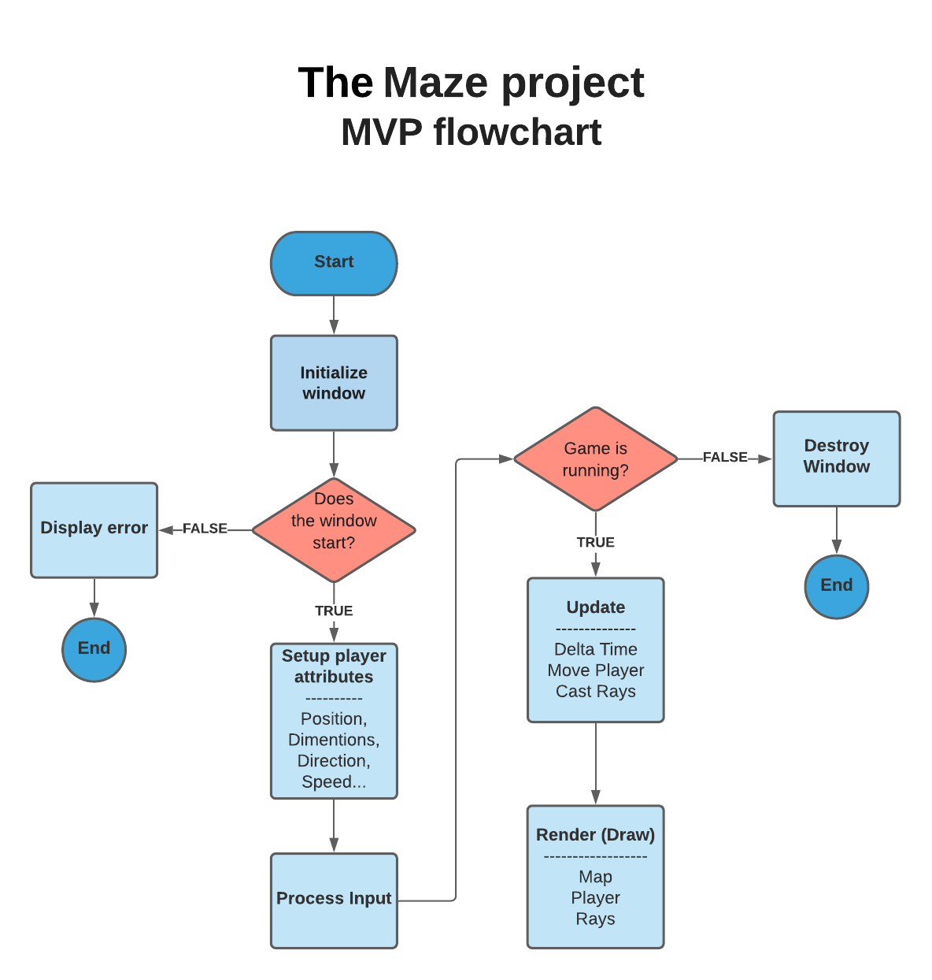

**THE MAZE DATA MODEL/STRUCTURE/ARCHITECTURE**

